**Web testing**

As part of the requirements I have been asked to carry out testing for my website. I will be testing my website on 3 different sites; Google Chrome, Firefox and Internet Explorer. As well as this, I will test the website on different resolutions to see the difference. Moreover, I will check my website against a html5 validator to see if there are any errors. If so these will be rectified. I have also tested out my website on different operating systems i.e. laptop. Finally, I will carry out a usability questionnaire through the use of a questionnaire where I will ask my peers to complete these.

**Browsers:**

1. Google Chrome:

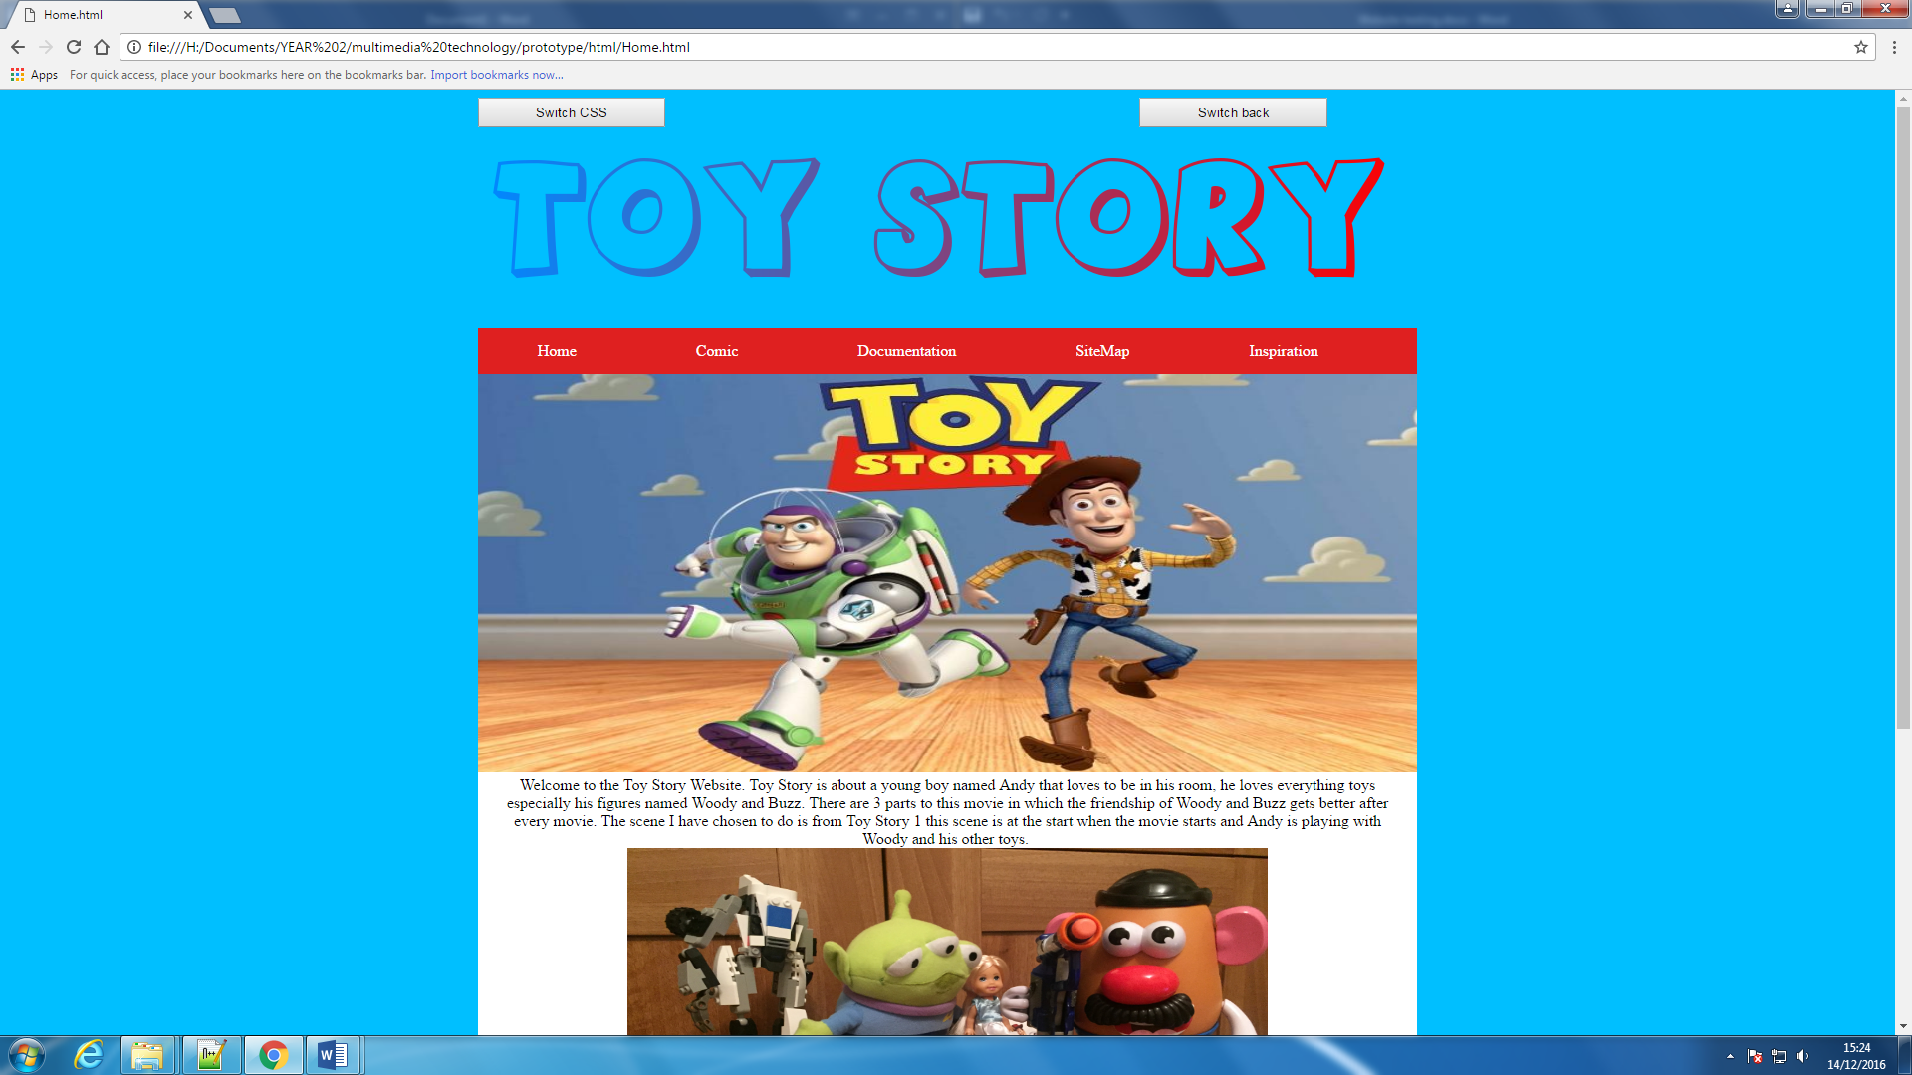

I have tested my website on Google Chrome and it worked. The colours still remain vibrant and nothing is distorted. The text is still readable and very easy to navigate around.

1. Internet Explorer

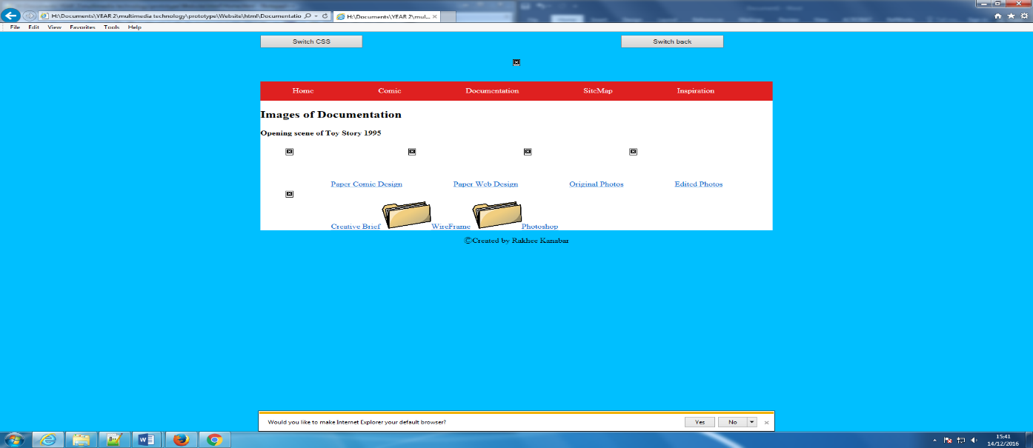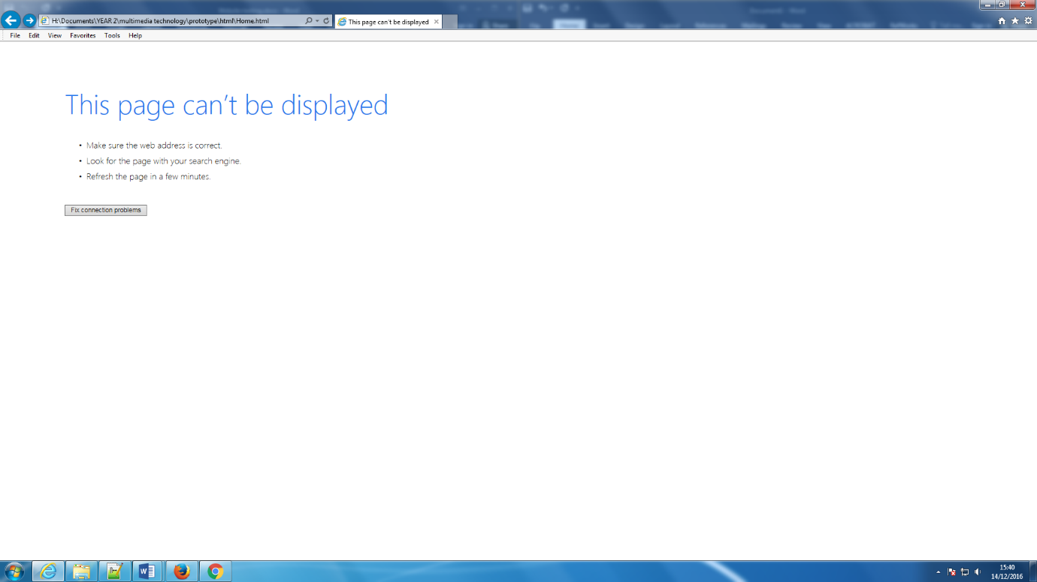When testing on internet explorer I had issues with my pictures showing, however the link would still work. The link will open the documents you want to display.

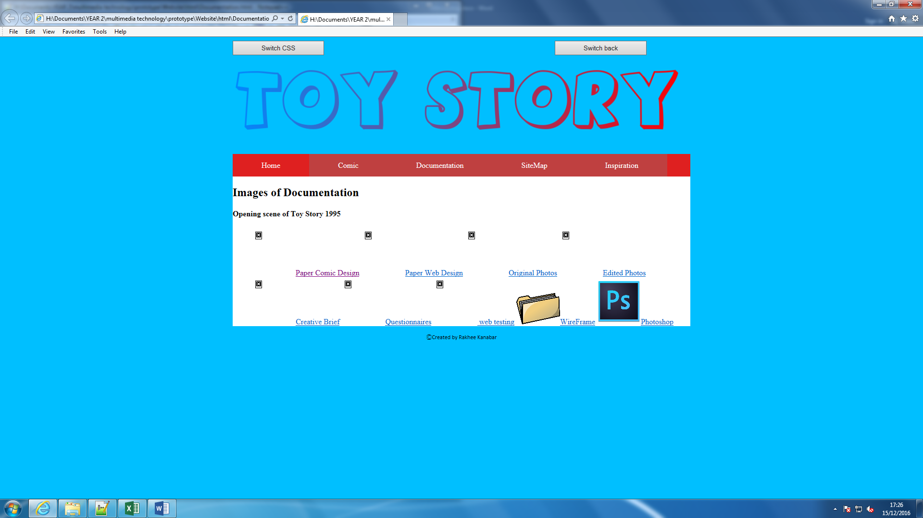

1. Firefox

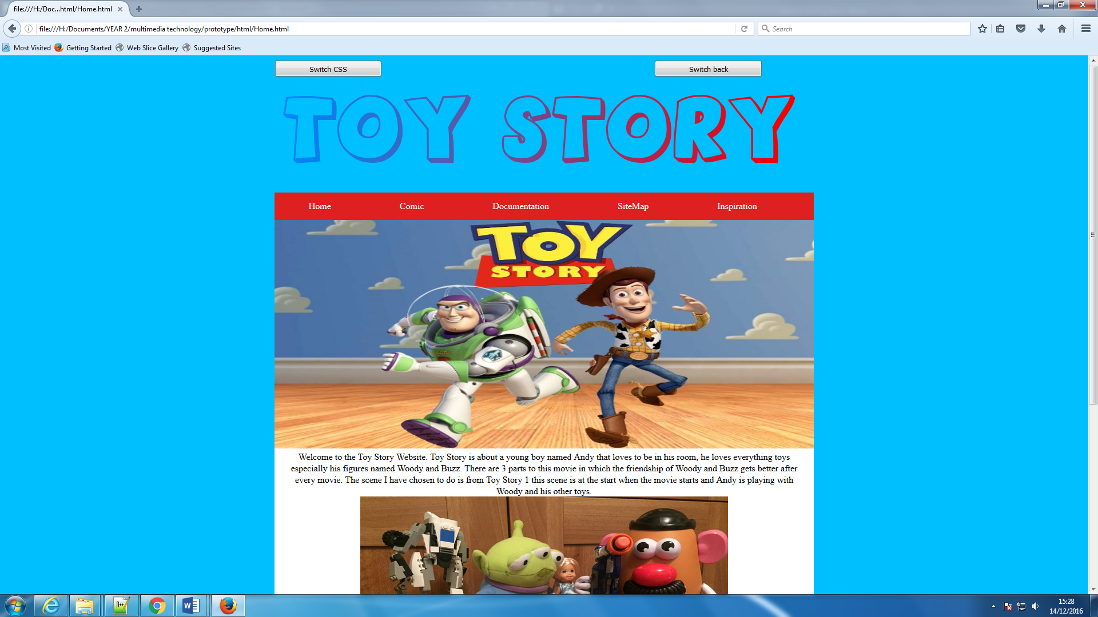

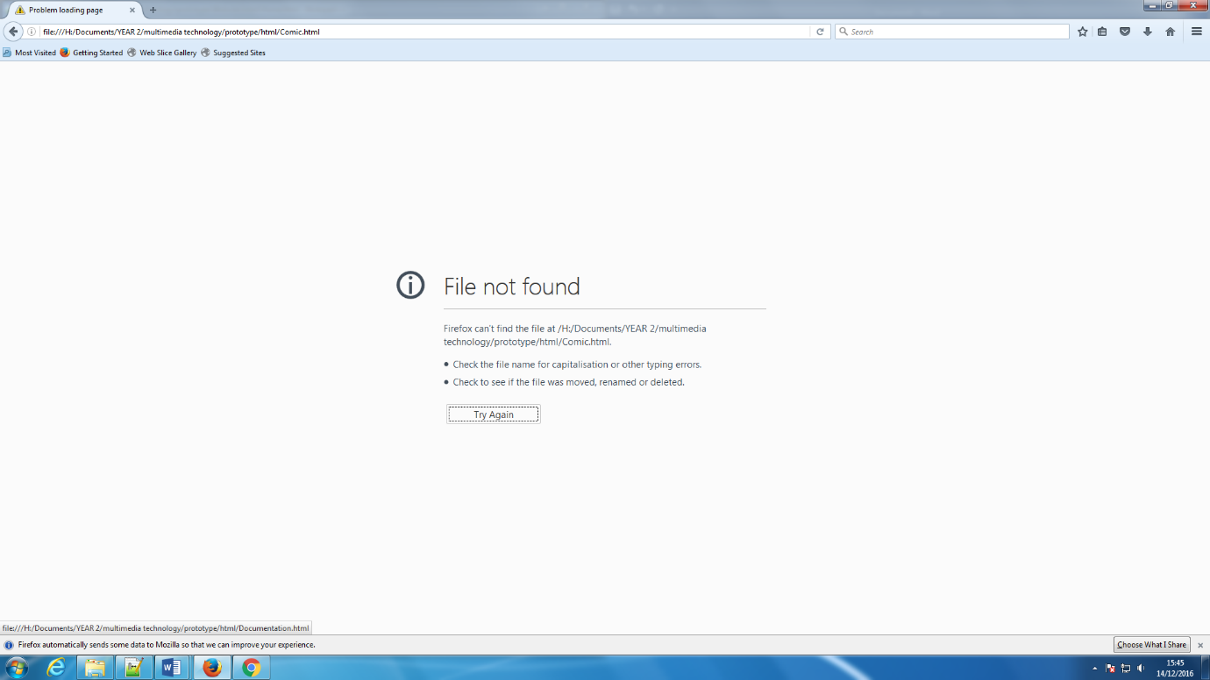Firefox was the only browser that struggled to display all pages. The only successful load up was the home page, the others displayed “File not found” other than that, the colours and fonts were still vibrant with the textures of the buttons looking a little bit more professional.

**Screen resolution:**

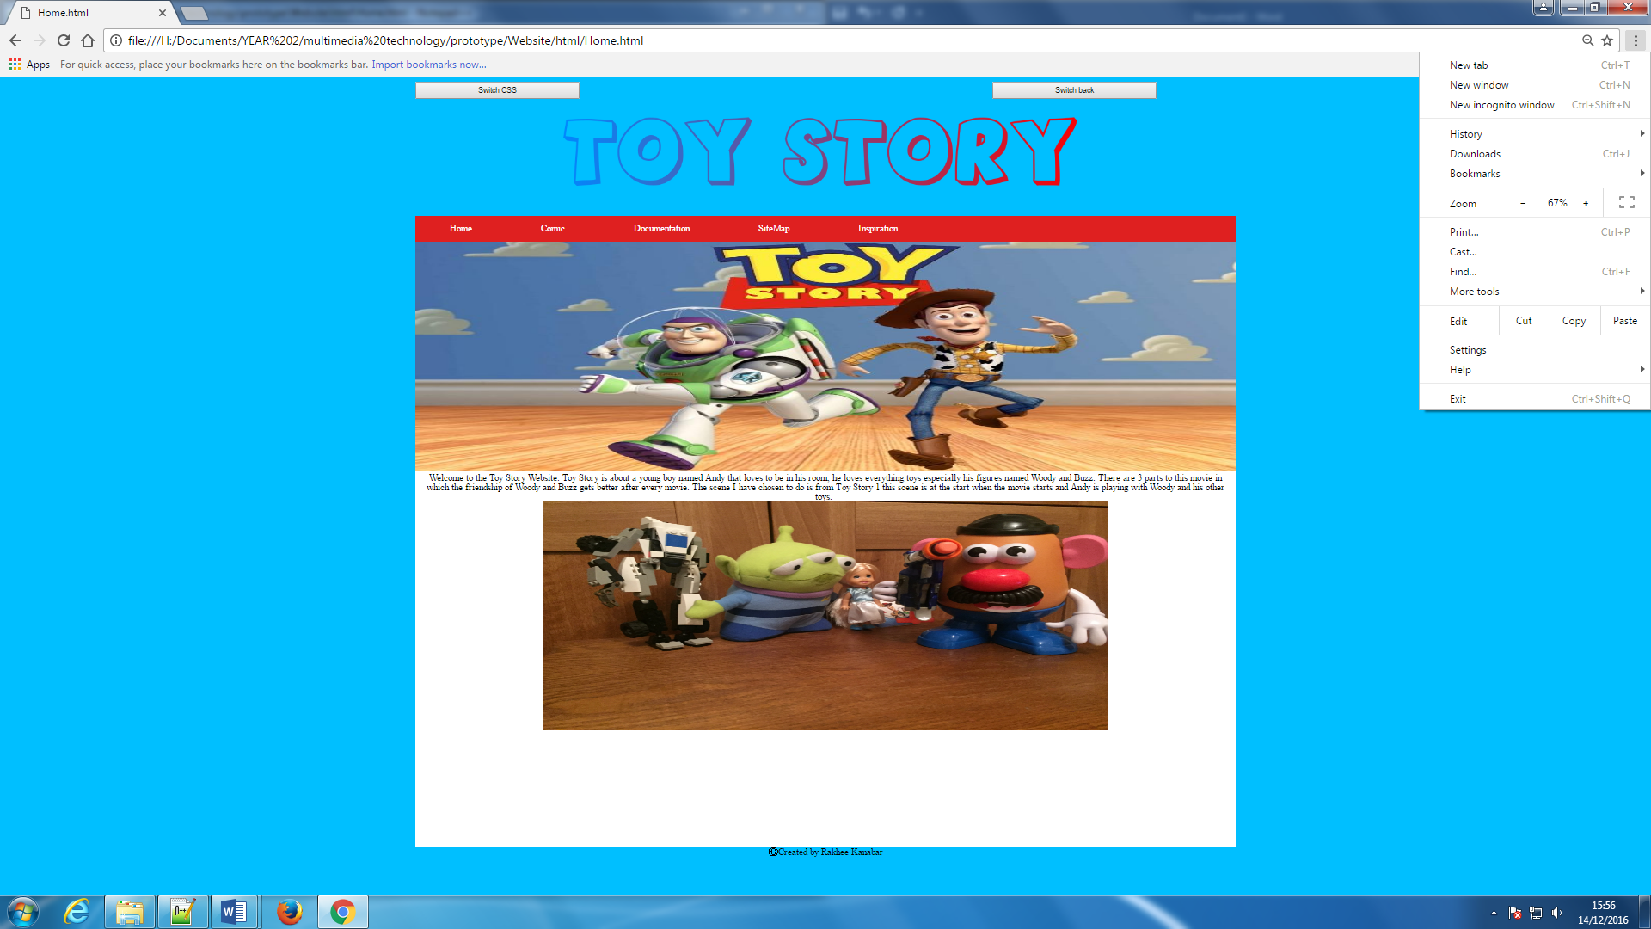

67%- it was harder to read the text when the resolution was changed to 67%, the text was smaller and the images became distorted.

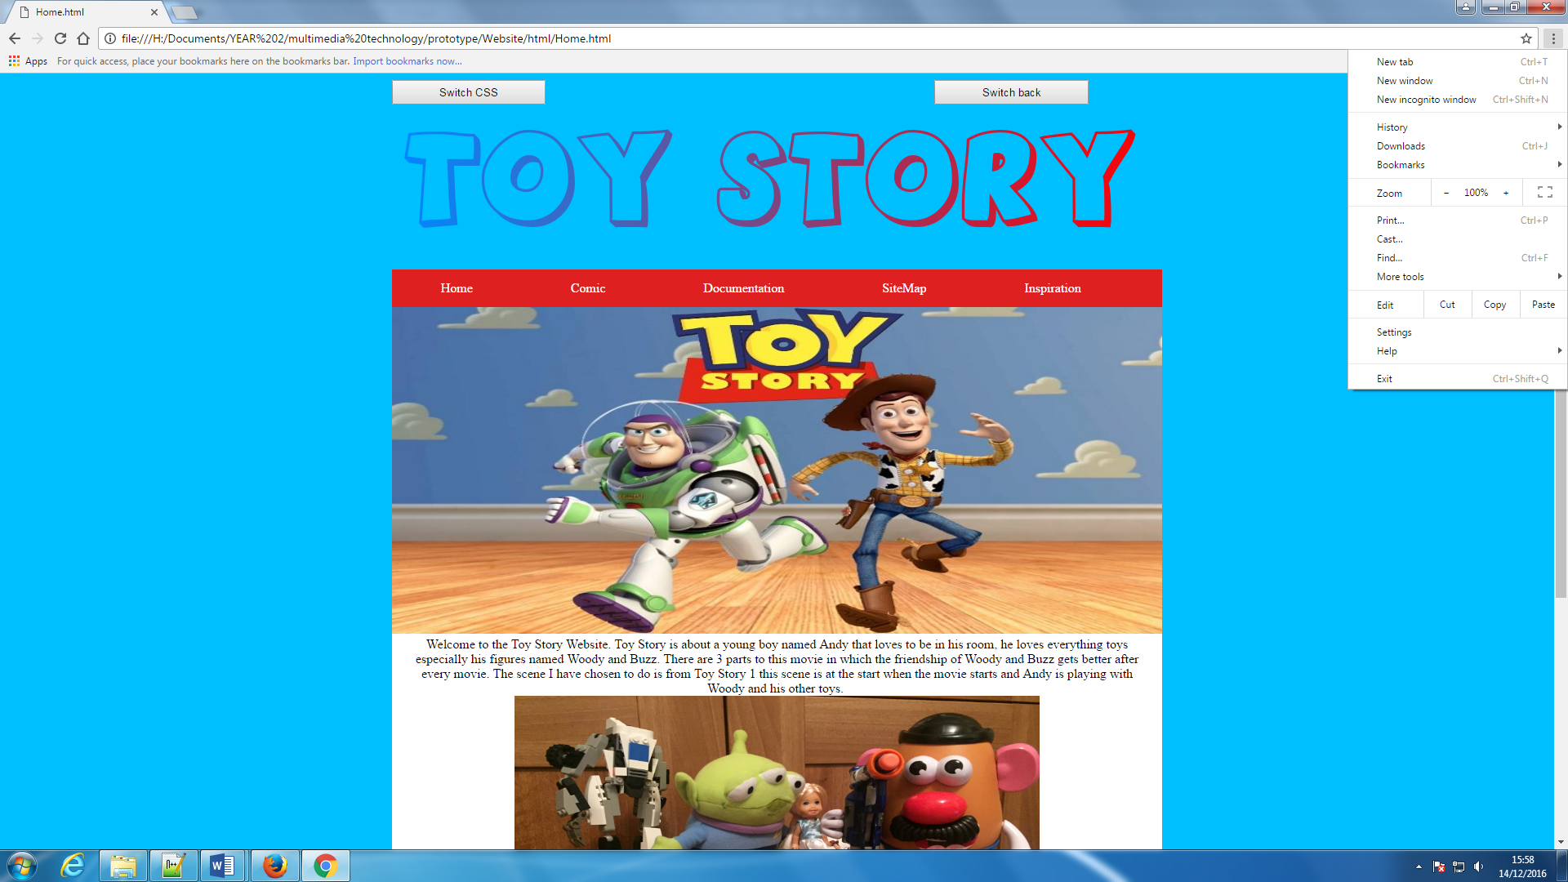

100% - when the resolution is on 100% everything is in proportion, the images are aligned properly and it is easy to navigate and read what is written on site.

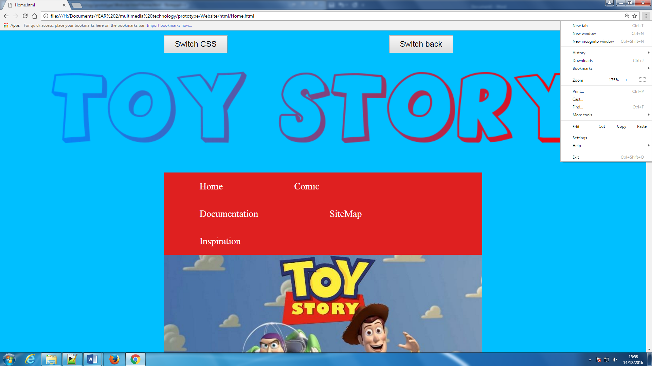

175% - when the resolution is zoomed in by 75% more, the logo increases, the buttons increase and the navigation bar moves out of place.

**Validation:**

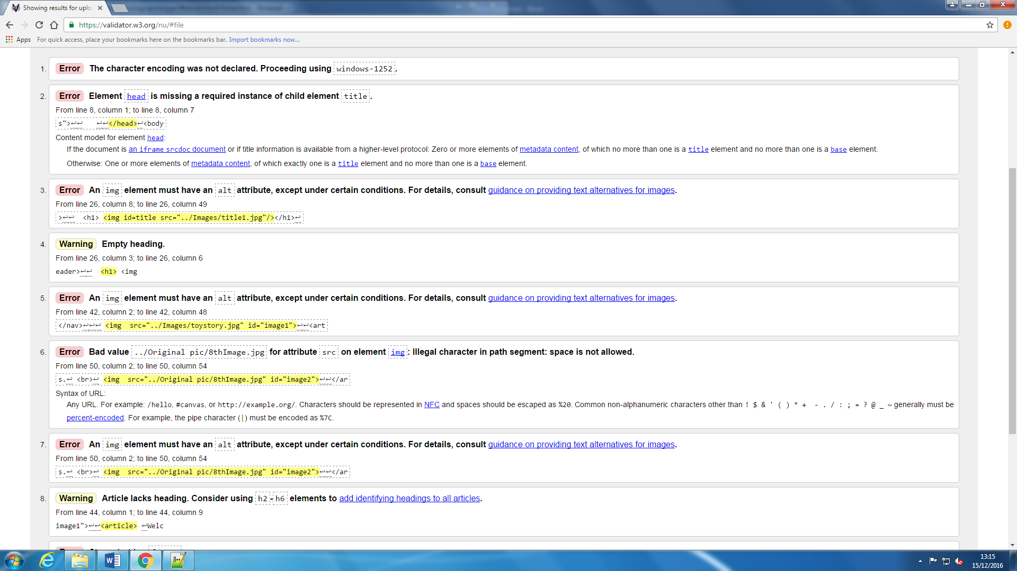

Error

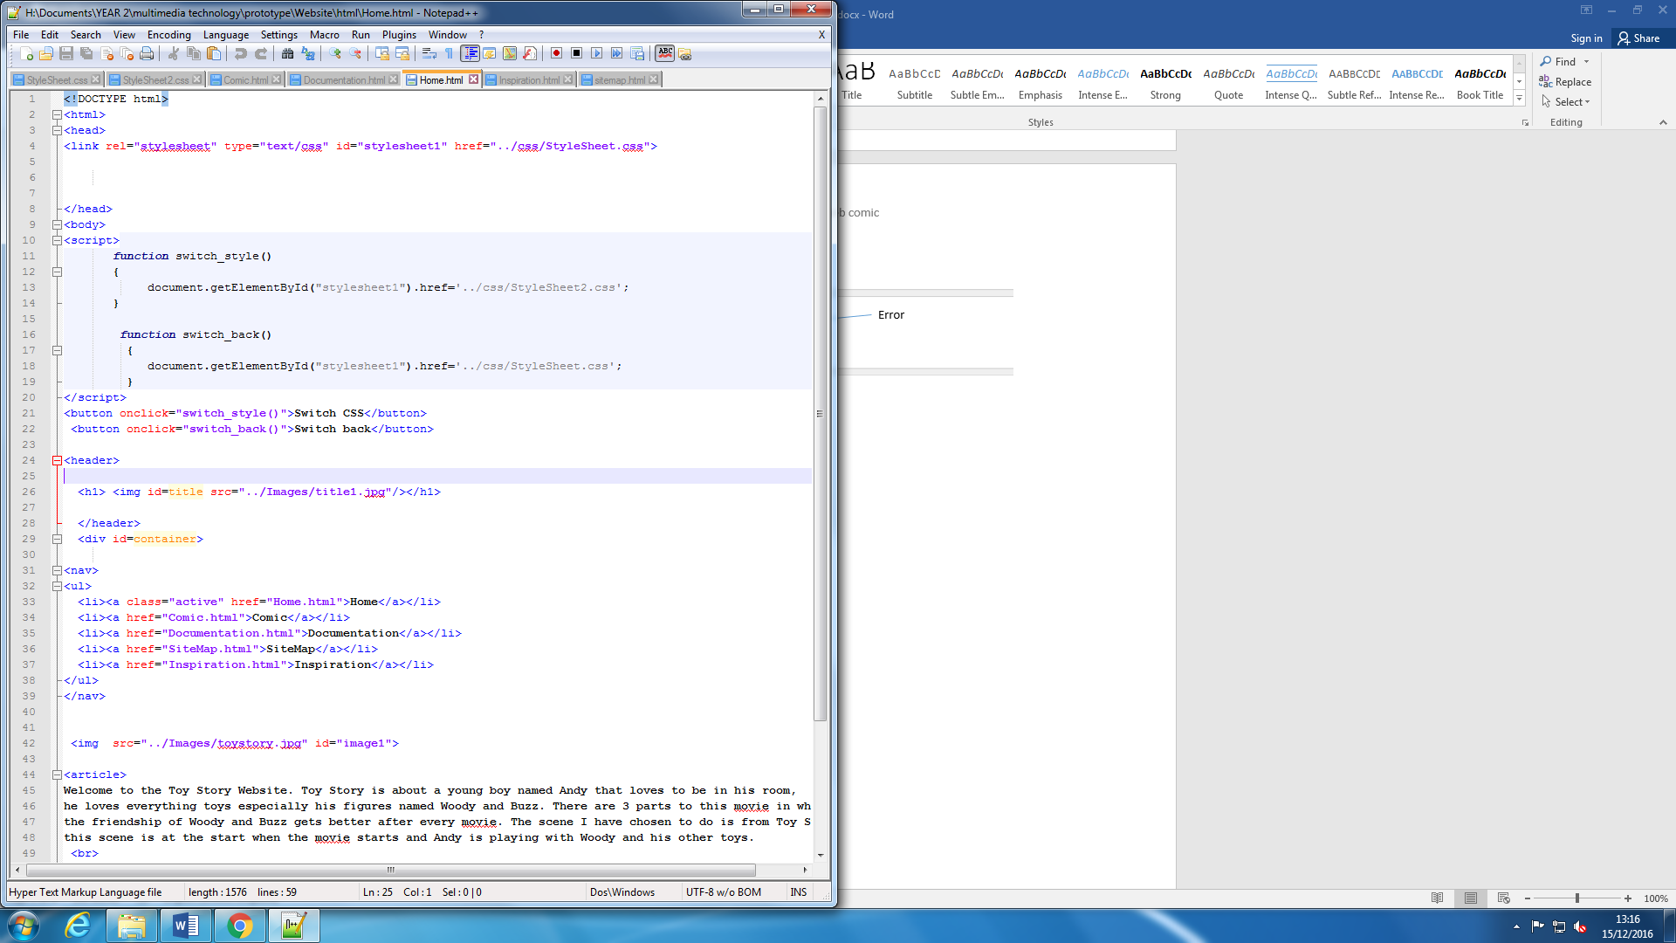

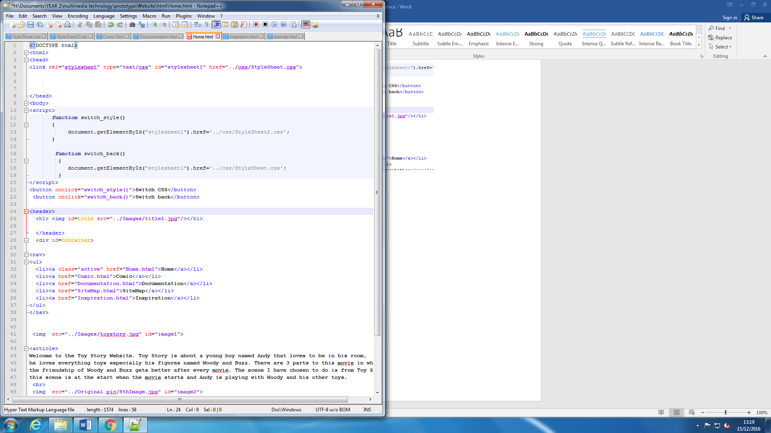

Solved

**CSS Validation:**

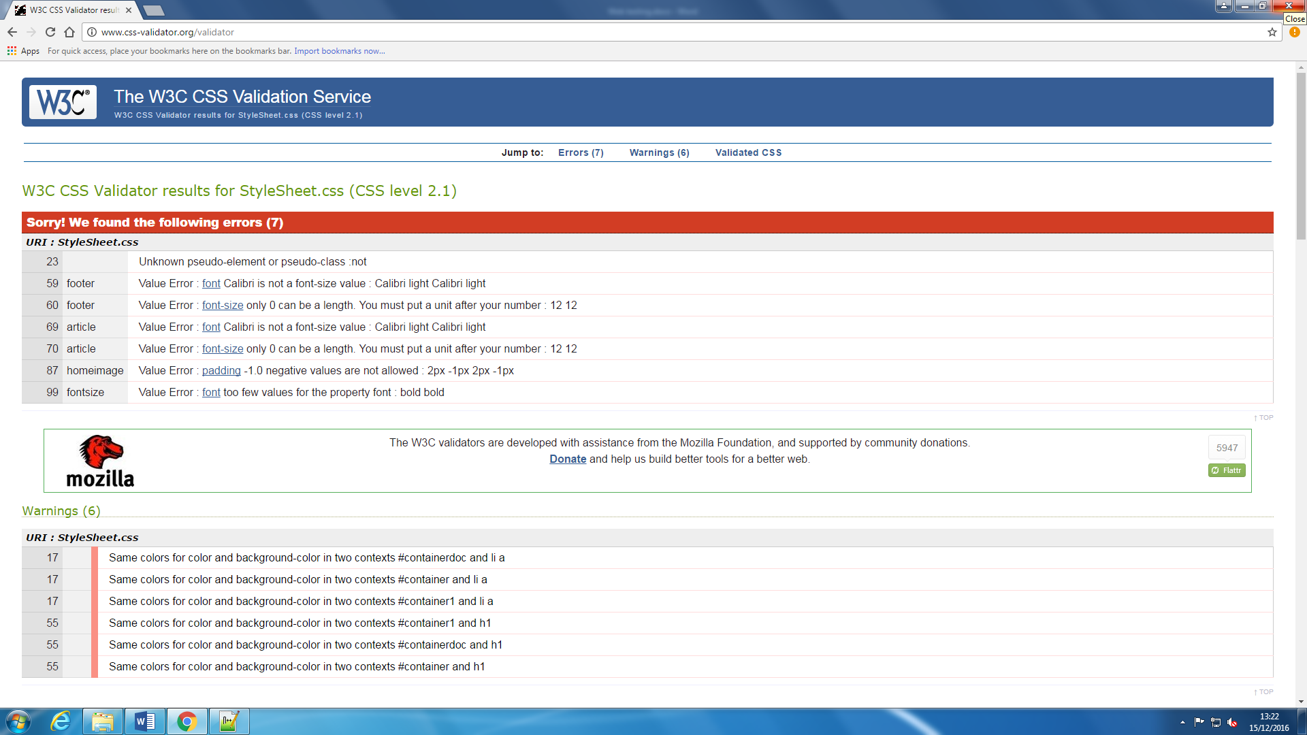

Validator shows 7 errors on the CSS

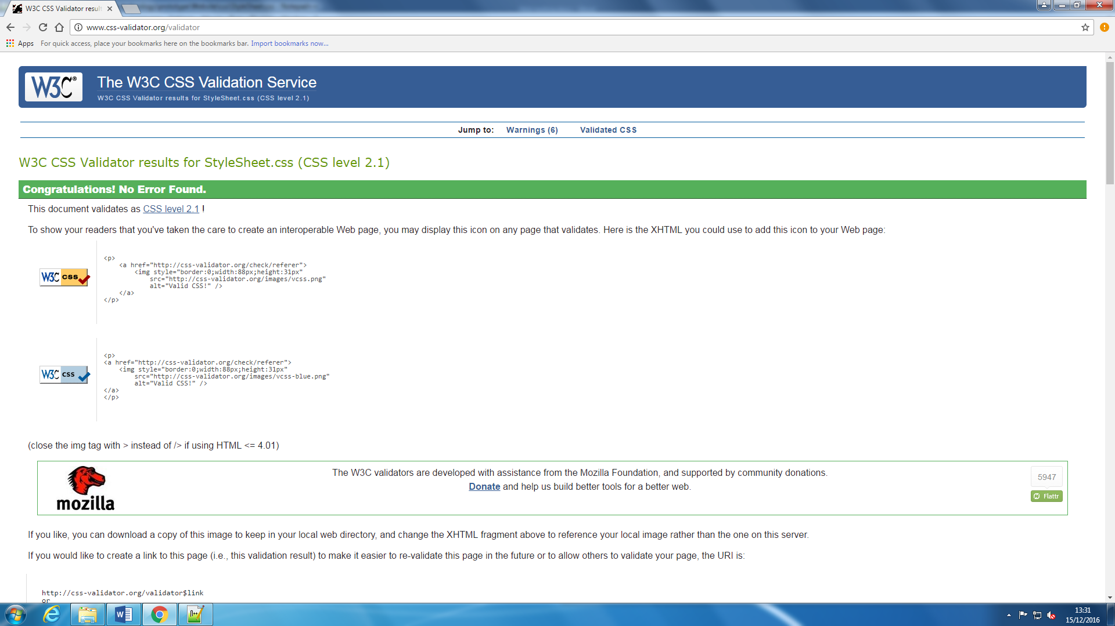

Errors fixed

**Different platform:**

Computer: website testing on the computer

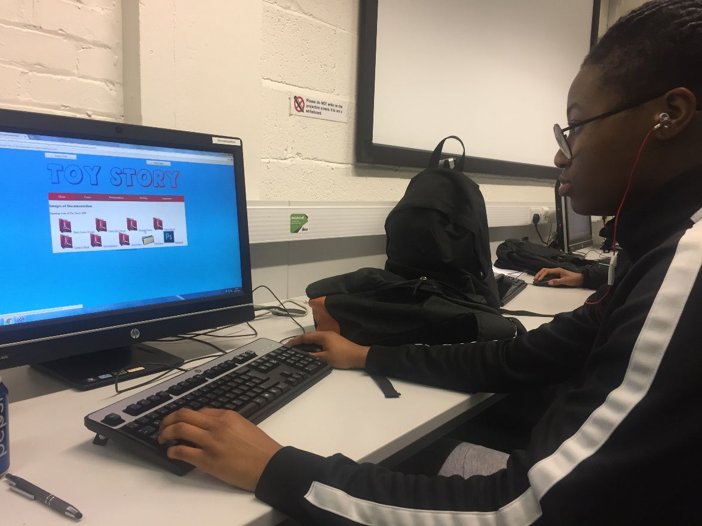

One way in which I tested my website usability was through asking a number of students to try my online comic, and navigate around it by themselves without any guidance. Overall, users found it easy to move around the website and open the documents, and go to any page they desired with ease.

**Laptop:** website testing on the laptop.

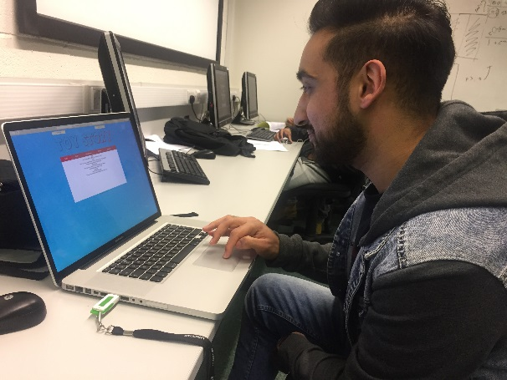 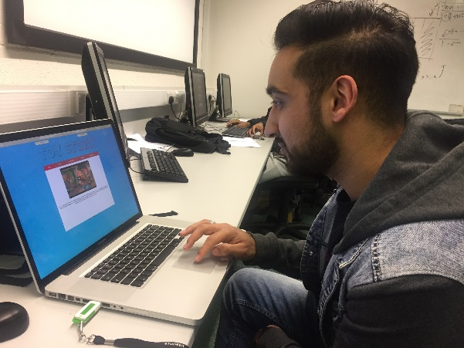

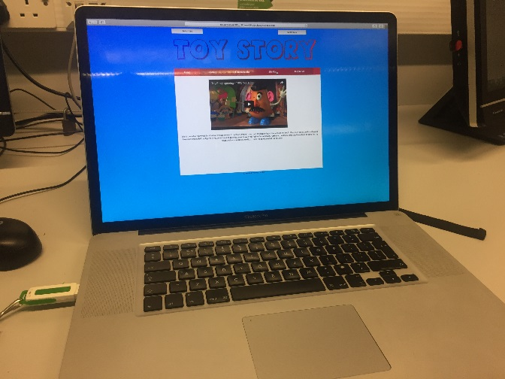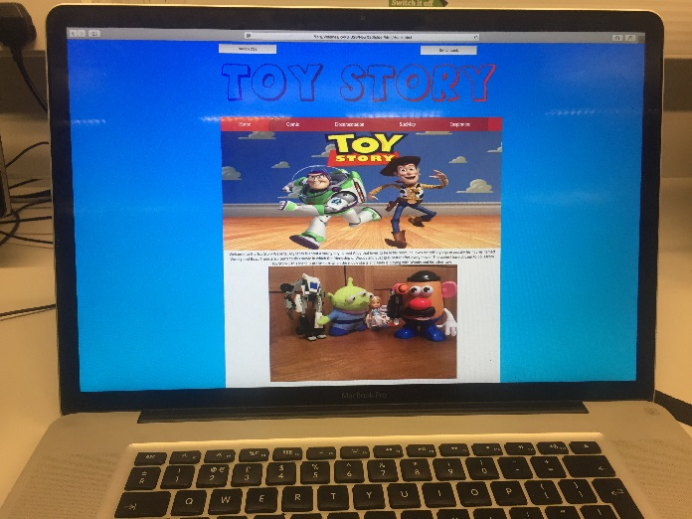

After trying out different screen resolutions and opening my site on different web browsers, I branched out and tried a different device. When opening it on the laptop, safari net nothing changed, it was still in porpotion, text was still reader and the navigation was faster.

**Spelling check**

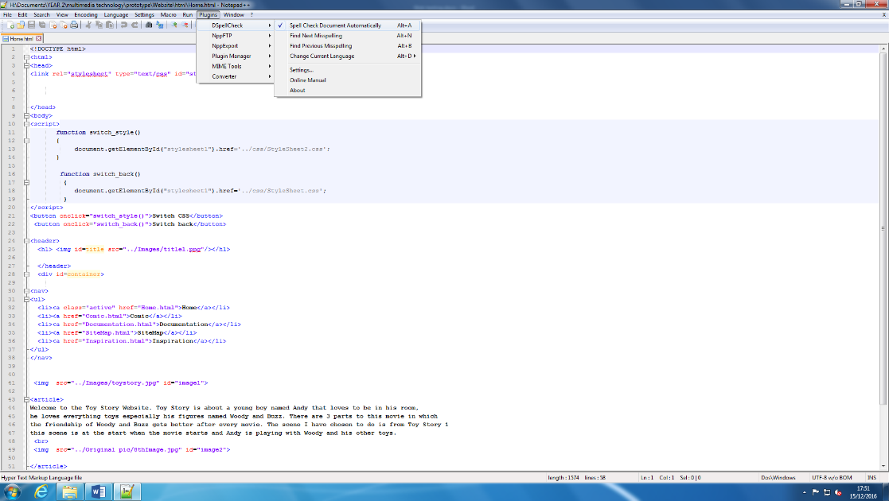

As part of my testing, in order to make sure that my spelling was correct, I changed the settings on notepad ++ to autocorrect my spelling.

**Questionaires – below are the results of my questionaires.**

